**Department of Public Safety**

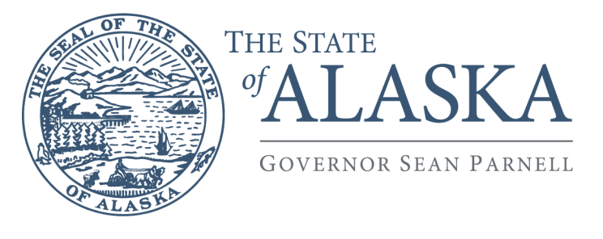

**Governor Bill Walker**

DIVISION OF STATEWIDE SERVICES

APSIN Security Unit

5700 East Tudor Road

Anchorage, Alaska 99507-1225

Main: 907.269.5790

Fax: 907.338-1051

# DEPARTMENT OF PUBLIC SAFETY/CJIS SYSTEMS AGENCY

# VILLAGE PUBLIC SAFETY OFFICER PROGRAM

# CRIMINAL RECORDS INFORMATION WAIVER

**APPLICANT SECTION:**

Name: ______________________________ Date of Birth: ____________ Sex: __

(Last, First Middle Suffix) (MM/DD/YYYY) (M/F)

Job Title: ________________________________ Employing Agency: ____________________________________________

Authorized Recipient for the Employing Agency**:** __________________________________________________________________

**WAIVER AGREEMENT**

The Department of Public Safety (DPS) has been designated by the Federal Bureau of Investigation (FBI) as the Criminal Justice Information Services (CJIS) Systems Agency (CSA) for the State of Alaska. I understand that by executing this request, I am agreeing that an investigation into my background through state and federal criminal history repositories, including the search of Alaska Public Safety Information Network (APSIN), National Crime Information Center (NCIC), and the Interstate Identification Index (III) will be conducted. I understand that I will be required to submit my fingerprints in connection with this request. I understand that the results of the investigation will be released to the CSA security personnel and the Alaska State Trooper Village Public Safety Officer (VPSO) program staff requesting this check on my behalf for use in determining suitability for the VPSO program consideration.

I authorize any law enforcement agency to release the above information to the Department of Public Safety. I also authorize the VPSO program staff to share the results from the APSIN (Alaska) criminal history record check with the authorized recipient of my employer (listed above). I understand that if I am found to have been convicted of a criminal offense or am found to be a fugitive from justice, it may negatively impact my application for participation in the Department of Public Safety VPSO program and/or my employment with the agency listed above.

I understand that I will receive a copy of the results from the state and national fingerprint criminal history record check. I further understand that I am entitled to challenge the accuracy and completeness of any information contained in any such report, as outlined in state law under 13 AAC 68 and in federal law under Title 28 Code of Federal Regulations Section 16.34, and that I may obtain a prompt determination as to the validity of my challenge before a final decision is made.

I understand that other than sharing the information as outlined above, no additional release of the results from this criminal history record request is authorized; I also understand that the information from this request will only be used for the authorized purpose outlined above. I certify that the information I have given on this form is true and correct to the best of my knowledge, and by signing below authorize the release and use of the criminal history record information as outlined in this waiver.

**Applicant Signature**: ______ **Date:** ___________________

***VPSO Program Staff Only***:

One legible fingerprint card* included with the Personnel Security Clearance Request Form:  Yes  No**

***\*****Client number on card should be 4003 for Direct APSIN/ARMS Access; 4156 for Building or Non-Direct System Access*

*\*\*Application cannot be processed*