Village Improvement Fund
Funding Application

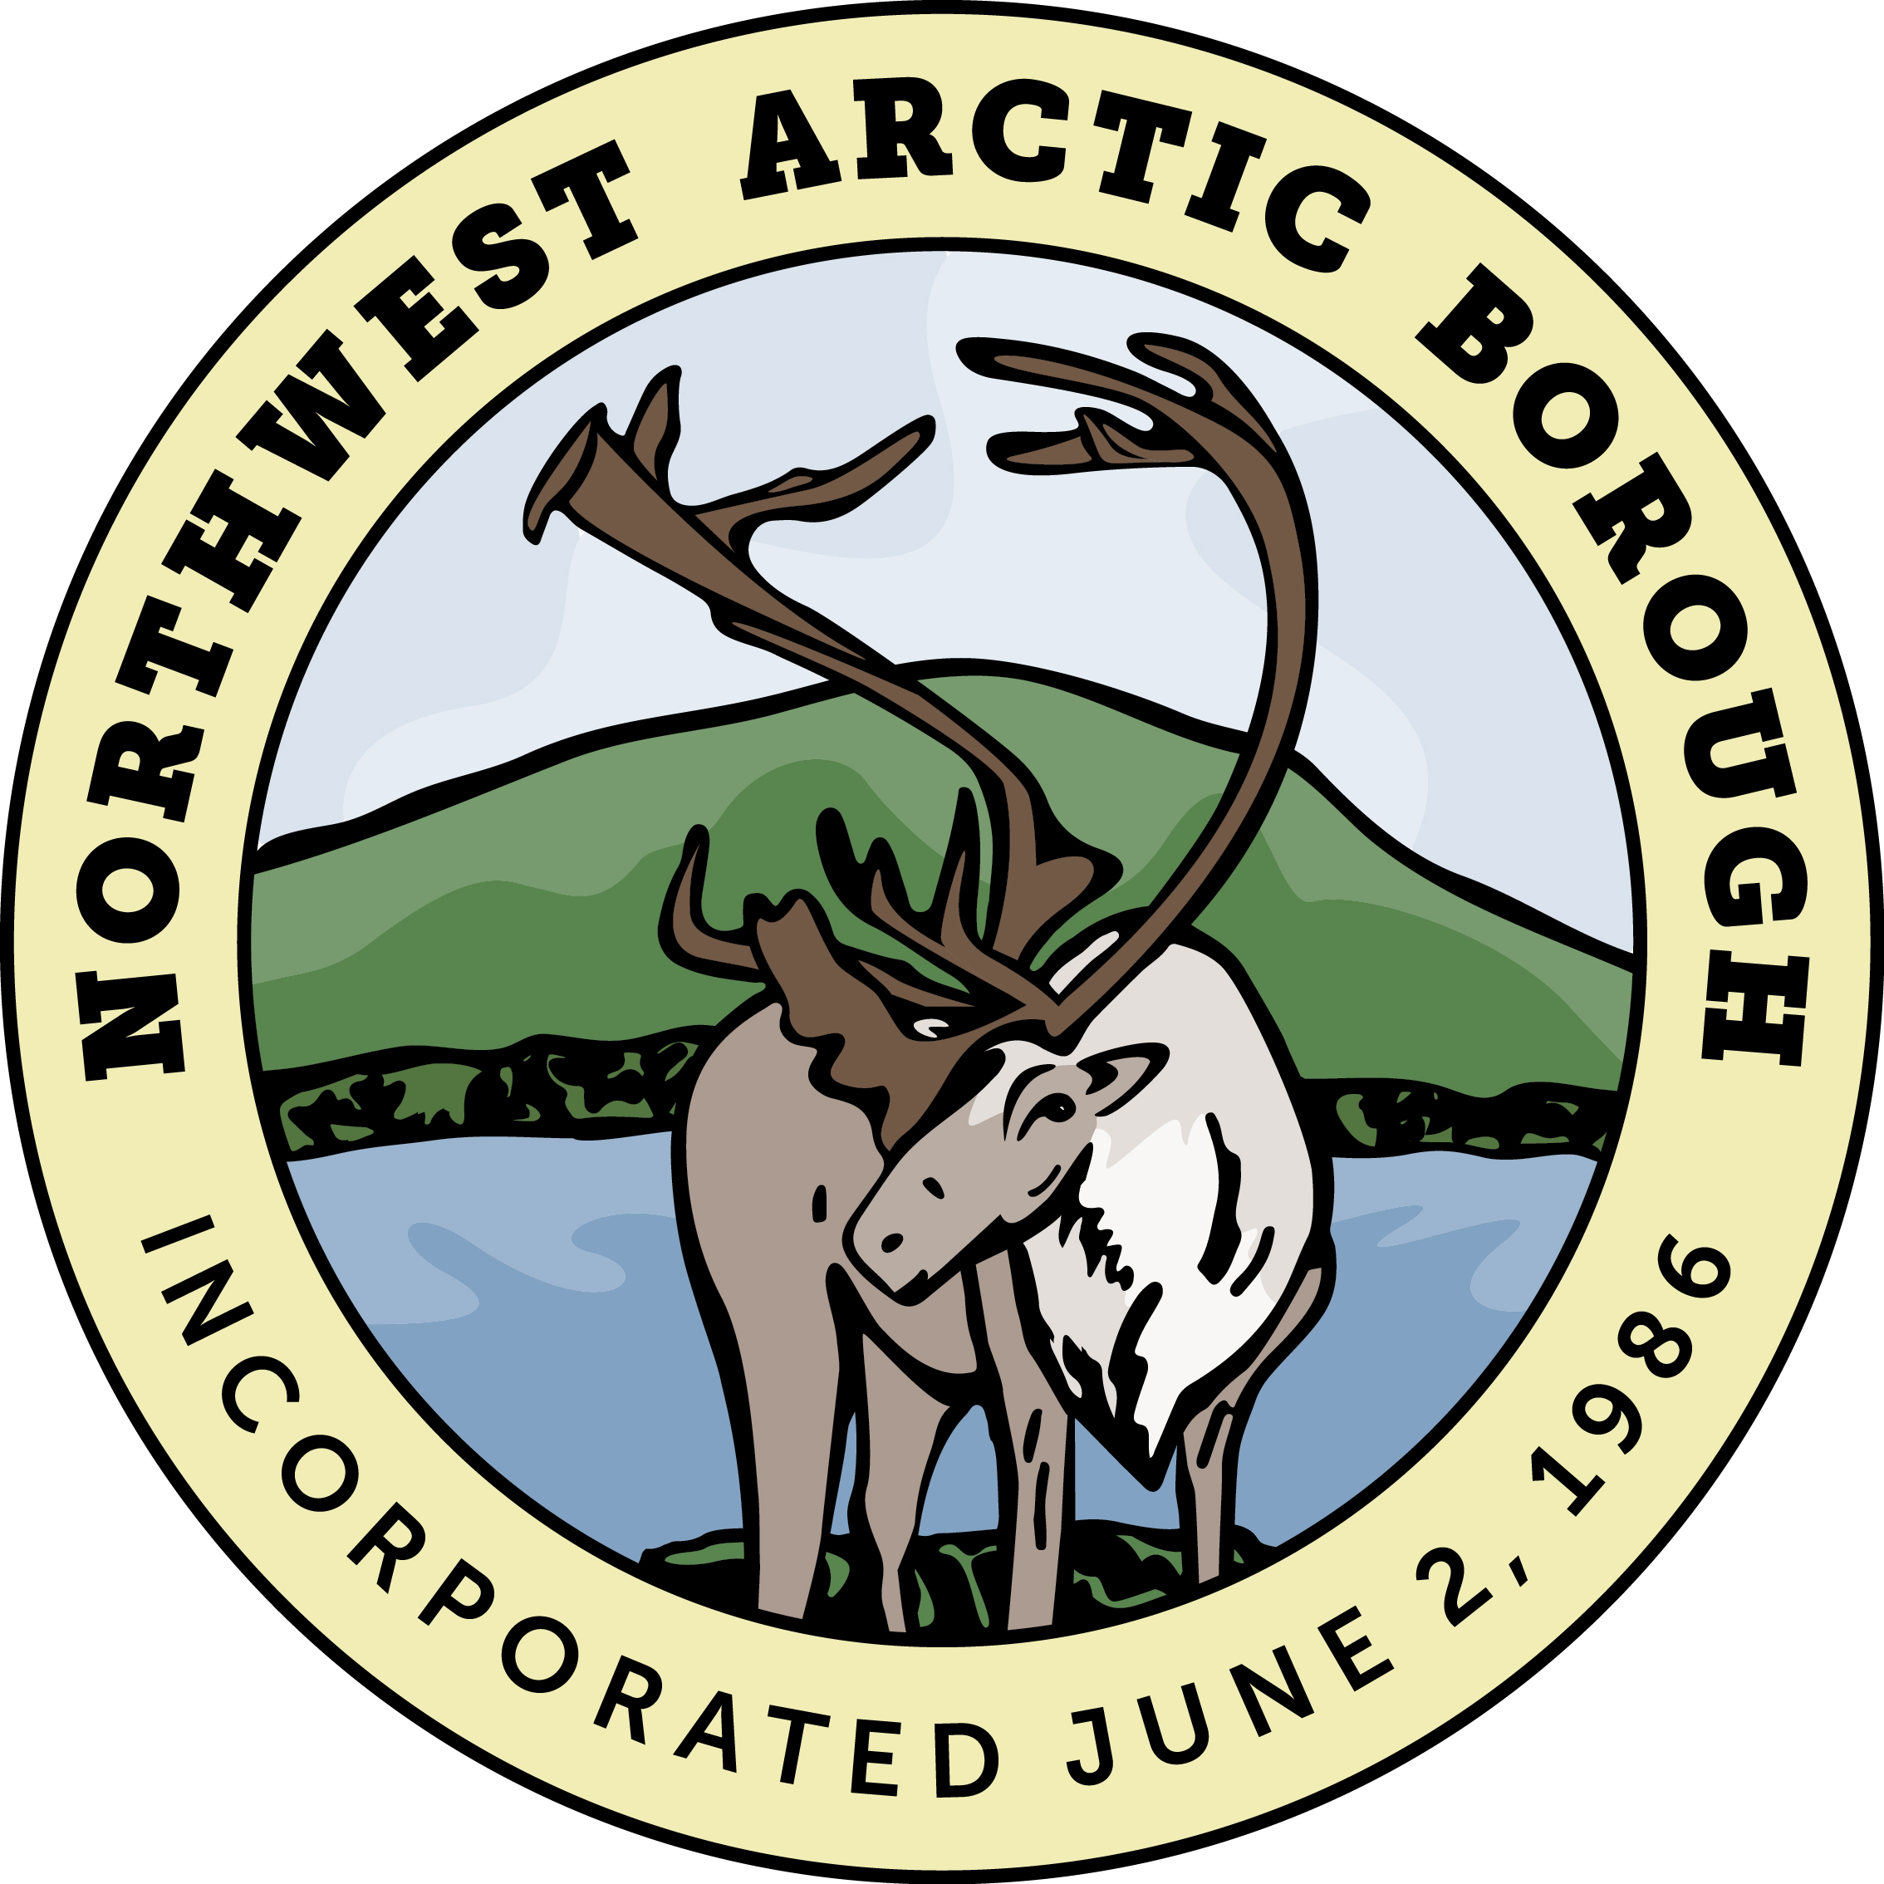

Strengthening and improving living and economic conditions for all residents

Table of Contents
Table of Contents 2
Part One: Organization/Group Profile 4
Part Two: Contact Information 4
Part Three: Funding Request Details 6
3.1 Application Project/program title: 6
3.2 What is the timeline for your project/program? 6
3.3 Is this an existing project/program (i.e. is it already operating or has construction started? Has the project/program delivered services already?) 6
3.4 What is the amount of the funding request to VIC? 7
3.5 Please describe how the VIF funds will be used for this project/program. 7
3.6 Does the project/program have other sources of funding, including matched funding or other grants (or state, community, partner organizations contributions)? If yes, please describe and attach relevant documentation. 7
3.7 Please attach a copy of the total project/program budget (including details on VIF funds and how other funding will be used. 7
3.8 Has the VIF provided funding to your community before? If you answered yes, please describe. 8
3.9 Has VIF provided funding to this Project/Program before? If you answered yes, please describe. 8
Part Four: Benefits 8
4.1 What are the short-term goals of the project/program? 8
4.1a What are the long-term goals of the project/program? 8
4.2 Who will benefit from the project/program? Please be specific (e.g. children, youth, elders, women, etc.) and include details (e.g. numbers). 9
4.3 What is the level of community impact? (i.e. will the broader community benefit or just a few individuals?) 9
4.4 Will the project benefit one Village, more than one Village, or multiple Villages in the Northwest Arctic region)? 9
4.5 Will the project create local jobs? If so, how many? 9
Part Five: Project Details 9
10
5.1 Will this Project/Program continue after VIF funding? Please describe why or why not. 10
5.1a (If yes) Describe how the project/program will be able to continue after VIF funding ends and by whom. 10
5.2 Please describe other projects in the community that could help support the success of this Project/Program? Circle Yes, No, 10
5.3 Are there any issues or other projects that could be negative for the success of your project? 10
5.4 Please explain how your organization has the administrative and management capacity to execute the project (i.e. financial software, audits history of management of other projects, stable relationships across community entities, and examples of other successful projects). 11
5.5 Please outline any experience your organization/staff has had with similar projects/programs. 11
5.6 Is the project/program “ready to go” or “shovel ready”? Please explain how it has considered the equipment, resources, people, and permits needed for success. 11
5.7 Does the project/program address an issue that is life threatening, or a health risk? (i.e. health and safety, emergency, danger to people, the environment, or property). Please describe. 11
5.8 Please describe if the project/program supports one or more priorities identified by the community. 12
5.9 Please attach any relevant documentation to show how the community was involved in or supports this project/program (examples could include letters of support, joint resolutions, priority lists, meeting minutes, sign up sheets etc.) 12
Option to include other relevant documentation 13
Certification 14

Part One: Organization/Group Profile

Village Name____________________________________________

Organization/Group Name _________________________________

Lead Organization for the Project/Program ____________________

Part Two: Contact Information

First Name_____________________________________________

Last Name (s) __________________________________________

Position/Title____________________________________________

Email _________________________________________________

Mailing Address_________________________________________

Phone________________________________________________

Alternate Contact
First Name____________________________________________

Last Name (s) _________________________________________

Position/Title___________________________________________

Email ________________________________________________

Mailing Address________________________________________

Phone________________________________________________

Project/Program Category

_____Program/Services (wellness, education, medical, cultural, etc)

_____Infrastructure (water, sewer, roads, construction, renovation, equipment, etc.)

Part Three: Funding Request Details

3.1 Application Project/program title:

____________________________________________________________________________________

____________________________________________________________________________________

3.2 What is the timeline for your project/program?
____________________________________________________________________________________

____________________________________________________________________________________

3.3 Is this an existing project/program (i.e. is it already operating or has construction started? Has the project/program delivered services already?)
____________________________________________________________________________________

____________________________________________________________________________________

3.4 What is the amount of the funding request to VIC?
____________________________________________________________________________________

____________________________________________________________________________________

3.5 Please describe how the VIF funds will be used for this project/program.
____________________________________________________________________________________

____________________________________________________________________________________

3.6 Does the project/program have other sources of funding, including matched funding or other grants (or state, community, partner organizations contributions)? If yes, please describe and attach relevant documentation.
____________________________________________________________________________________

____________________________________________________________________________________

3.7 Please attach a copy of the total project/program budget (including details on VIF funds and how other funding will be used.

____________________________________________________________________________________

____________________________________________________________________________________

3.8 Has the VIF provided funding to your community before? If you answered yes, please describe.
____________________________________________________________________________________

____________________________________________________________________________________

3.9 Has VIF provided funding to this Project/Program before? If you answered yes, please describe.
____________________________________________________________________________________

____________________________________________________________________________________

Part Four: Benefits

4.1 What are the short-term goals of the project/program?
____________________________________________________________________________________

____________________________________________________________________________________

4.1a What are the long-term goals of the project/program?
____________________________________________________________________________________

____________________________________________________________________________________

4.2 Who will benefit from the project/program? Please be specific (e.g. children, youth, elders, women, etc.) and include details (e.g. numbers).
____________________________________________________________________________________

____________________________________________________________________________________

4.3 What is the level of community impact? (i.e. will the broader community benefit or just a few individuals?)
____________________________________________________________________________________

____________________________________________________________________________________

4.4 Will the project benefit one Village, more than one Village, or multiple Villages in the Northwest Arctic region)?
____________________________________________________________________________________

____________________________________________________________________________________

4.5 Will the project create local jobs? If so, how many?
____________________________________________________________________________________

____________________________________________________________________________________

Part Five: Project Details

5.1 Will this Project/Program continue after VIF funding? Please describe why or why not.
____________________________________________________________________________________

____________________________________________________________________________________

5.1a (If yes) Describe how the project/program will be able to continue after VIF funding ends and by whom.
____________________________________________________________________________________

____________________________________________________________________________________

5.2 Please describe other projects in the community that could help support the success of this Project/Program? Circle Yes, No,
____________________________________________________________________________________

____________________________________________________________________________________

5.3 Are there any issues or other projects that could be negative for the success of your project?
____________________________________________________________________________________

____________________________________________________________________________________

5.4 Please explain how your organization has the administrative and management capacity to execute the project (i.e. financial software, audits history of management of other projects, stable relationships across community entities, and examples of other successful projects).
____________________________________________________________________________________

____________________________________________________________________________________

5.5 Please outline any experience your organization/staff has had with similar projects/programs.
____________________________________________________________________________________

____________________________________________________________________________________

5.6 Is the project/program “ready to go” or “shovel ready”? Please explain how it has considered the equipment, resources, people, and permits needed for success.
____________________________________________________________________________________

____________________________________________________________________________________

5.7 Does the project/program address an issue that is life threatening, or a health risk? (i.e. health and safety, emergency, danger to people, the environment, or property). Please describe.
____________________________________________________________________________________

____________________________________________________________________________________

5.8 Please describe if the project/program supports one or more priorities identified by the community.
____________________________________________________________________________________

____________________________________________________________________________________

5.9 Please attach any relevant documentation to show how the community was involved in or supports this project/program (examples could include letters of support, joint resolutions, priority lists, meeting minutes, sign up sheets etc.)
____________________________________________________________________________________

____________________________________________________________________________________

Option to include other relevant documentation

Please attach as much supporting documentation as you can. Examples of useful documentation that you could attach might include:

- Detailed budget including how VIF dollars will be used
- Details on match funding
- Detailed project/program timeline including resources
- Joint resolutions
- Letters of support from the community/organizations
- Meeting minutes or sign in sheets showing community support
- Resumes (i.e. of project manager or lead for the Project)
- Letters of recommendation
- Relevant permits or related documents (i.e. property ownership, site control, potential subsistence impacts, studies)
- Relevant insurance information (i.e. workers compensation, liability insurance, bonding insurance)
- Most recent audit

Certification

I certify that I am authorized on behalf of ____________________________

to submit this application on behalf of the community of ________________

and that it is complete to the best of my knowledge.

__________________________ _________________________
Applicant Signature Printed Name/Date

__________________________ __________________________
Title Organization submitting application

__________________________ _________________________
Alternate Applicant Signature Printed Name/Date

__________________________ __________________________
Title Organization submitting application

VIF Staff certification

___________________________________________________
Date received: Name/Title

