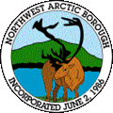 | Northwest Arctic Borough  Fire Department  Ambler Buckland Candle Deering Kiana Kivalina  Kobuk Kotzebue Noatak Noorvik Selawik Shungnak | 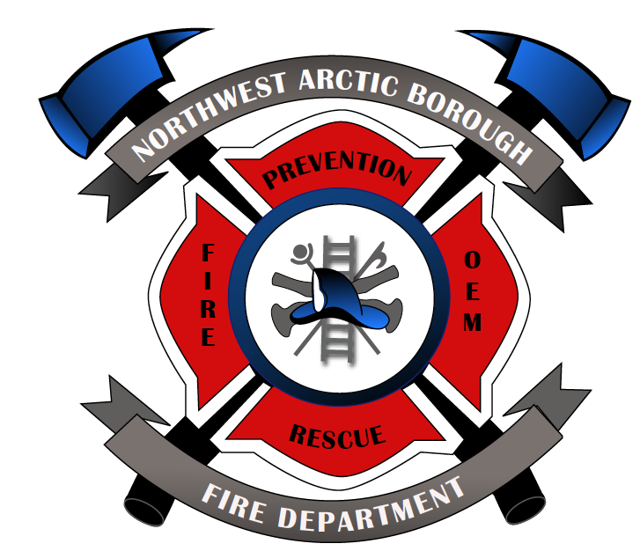

APPLICATION FOR MEMBERSHIP

Name: __________________________ DOB___________ SSN ___________

Address: _________________________________________________________

Street/PO Box City State Zip Code

Telephone #s: ____________________________________________________

What capacity would you like to serve (i.e. communications, operations, support)? ________________________________________________________________________________________________________________________________________________________________________________________________

What type(s) of training are you interested in? ___________________________
________________________________________________________________________________________________________________________________________________________________________________________________

What type(s) of training and/or certification(s) do you already have? __________
________________________________________________________________________________________________________________________________________________________________________________________________

When are you available to volunteer? __________________________________
________________________________________________________________________________________________________________________________________________________________________________________________

Do you possess a valid Alaska Driver’s license? ____ YES ____ NO

ADL#: __________ Expiration date: __________

Have you ever been convicted of a felony or misdemeanor? ____ YES ____ NO
If yes, please explain: _________________________________________
_________________________________________________________________________________________________________________________________________________________________________________

I, _____________________________________, hereby apply for membership in
^{Printed Name}
the Northwest Arctic Borough Fire Department (NABFD). In submission of this application, I also agree to:

- Abide by all local, state, and federal and OSHA requirements for emergency responders.

- Abide by the rules and regulations of the NABFD.

- Allow the NABFD to conduct a background investigation, including but not limited to: academic credential(s) and license(s) (status, expiration dates, and related disciplinary actions), credit reports, criminal conviction records, driving records, and professional references. A form authorizing such a background check must be signed as part of this application process.)

- Be supportive of the NABFD in community affairs, keeping in mind that the health and safety of the citizens of the community and the prevention of fire are the primary task of all members of the NABFD.

- Give as freely of my time and energies to the NABFD as I am able.

- Maintain a professional attitude and patient confidentiality with regards to all emergency calls and information that I may be privileged to my duties.

- Obey the commands and instructions of my superior officers, to the best of my abilities, while on the emergency scene, in the station, and during all NABFD activities.

In case of emergency, whom should we notify?

Name: __________________________ Telephone (home/work): __________________

The information I have provided herein is true and accurate to the best of my knowledge.

___________________________ __________________________

^{Applicant Signature} ^{Date}

___________________________ __________________________

^{NABFD Fire Administrator} ^{Date}

___________________________
^{Probation Start Date}

