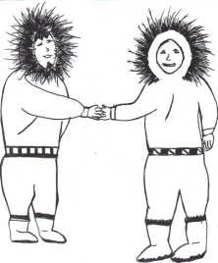

NATIVE VILLAGE OF NOATAK
P.O. BOX 89
NOATAK, ALASKA 99761
PHONE: (907) 485-2173
FAX: (907) 485-2137

Effective immediately

May 01, 2020 through May 31, 2020

- Traveler’s returning back to Noatak needs to self-quarantine at home for 14 days. Medical travel allowed only by the health care providers.
- No outside visitors.
- No inter village travel.

- There will be times for elders and adults for shopping time; No more than 10 customers.
- No child 18 years or younger will be allowed in public offices/store.

- Public gatherings of 10 or more will be prohibited.

- Although the IRA will be closed to the public, you may come and pay your bills if needed.

For more information visit www.cdc.gov or www.who.gov

Sincerely,

Noatak Village Council

